**Team 7: Waving Recipes**

**Spring 2020: CS-157A Sec 80 Class Project**

**Contributors**

* Mina Lee
* Guiller Dalit
* Sushil Karki

**Project Overview**

This project will be a database that collects the users’ recipes. The purpose of this project is to provide an efficient environment for people for their cooking recipes and save their recipes for their future needs.

**Hardware and software used:**

* IntelliJ IDEA Ultimate Edition Platform (Coding)
* Git & Github ( Version-Control)
* Apache Tomcat (Web-Server)
* MySql Workbench (Database)
* Mysql-connector-java-5.1.49-bin.jar)
* [Commons-fileupload-1.4.jar](http://commons.apache.org/proper/commons-fileupload/download_fileupload.cgi)
* [Commons-io-2.7.jar](https://commons.apache.org/proper/commons-io/download_io.cgi)

**RDMBS**

* MySql Workbench

**Application languages**

* Java(JDBC), MySql (SQL), CSS, HTML, XML, JavaScript

**Functional Requirements**

The overview of our project is an example of front-end and back-end architecture. HTML/CSS will be used to design front-end environments where we create a register and login to access inside the main page. Each user has to create an account with First name, Last name and password with the securely stored inside MySQL database. When the user tries to log in inside the system, the login credentials entered by the user will be matched with the login details in the database in order to authenticate the user. If the entered credentials are matched with database credentials, the user is granted access to the main page of the project. Our backend-end architecture is handled by primarily Java and MySql combinations. Images are used for educational purposes only. Nothing more.

**SignUp & SingIn Page**

[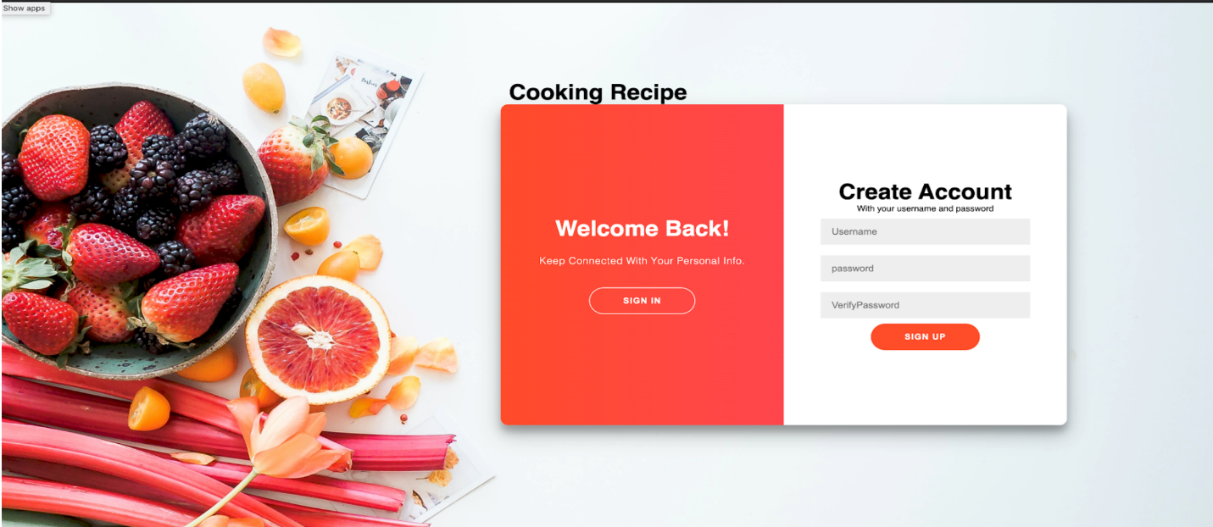](https://github.com/guiller-d/waving_recipes/blob/master/screenshots/cr1.png)

**Main Page**

[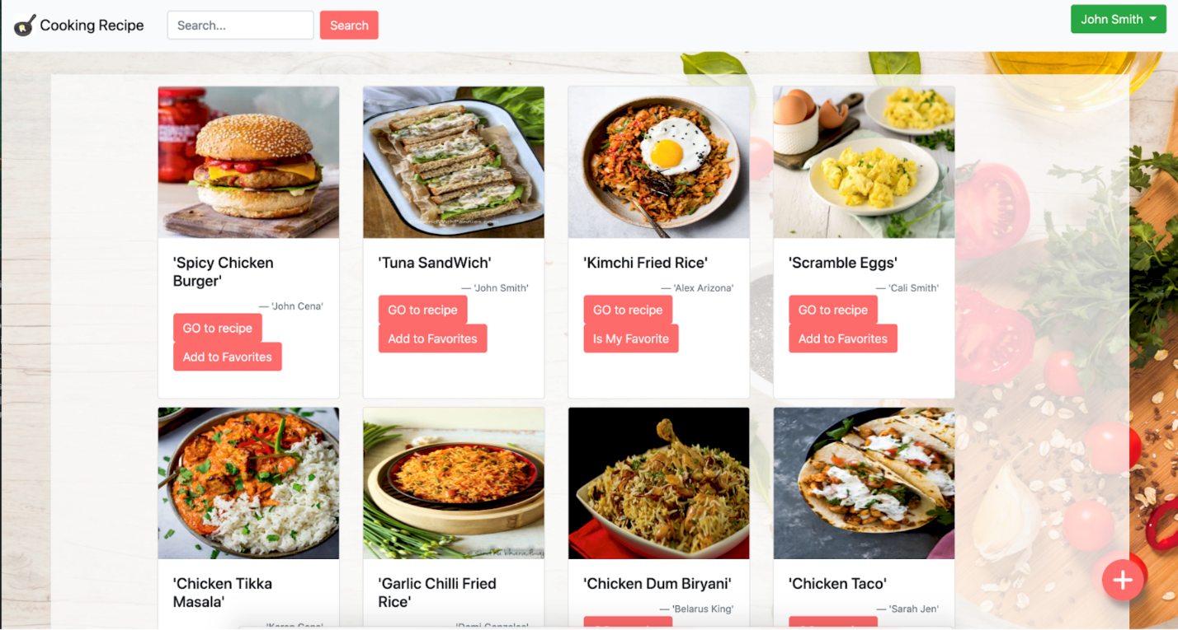](https://github.com/guiller-d/waving_recipes/blob/master/screenshots/cr3.png)

**Display Recipe Page**

[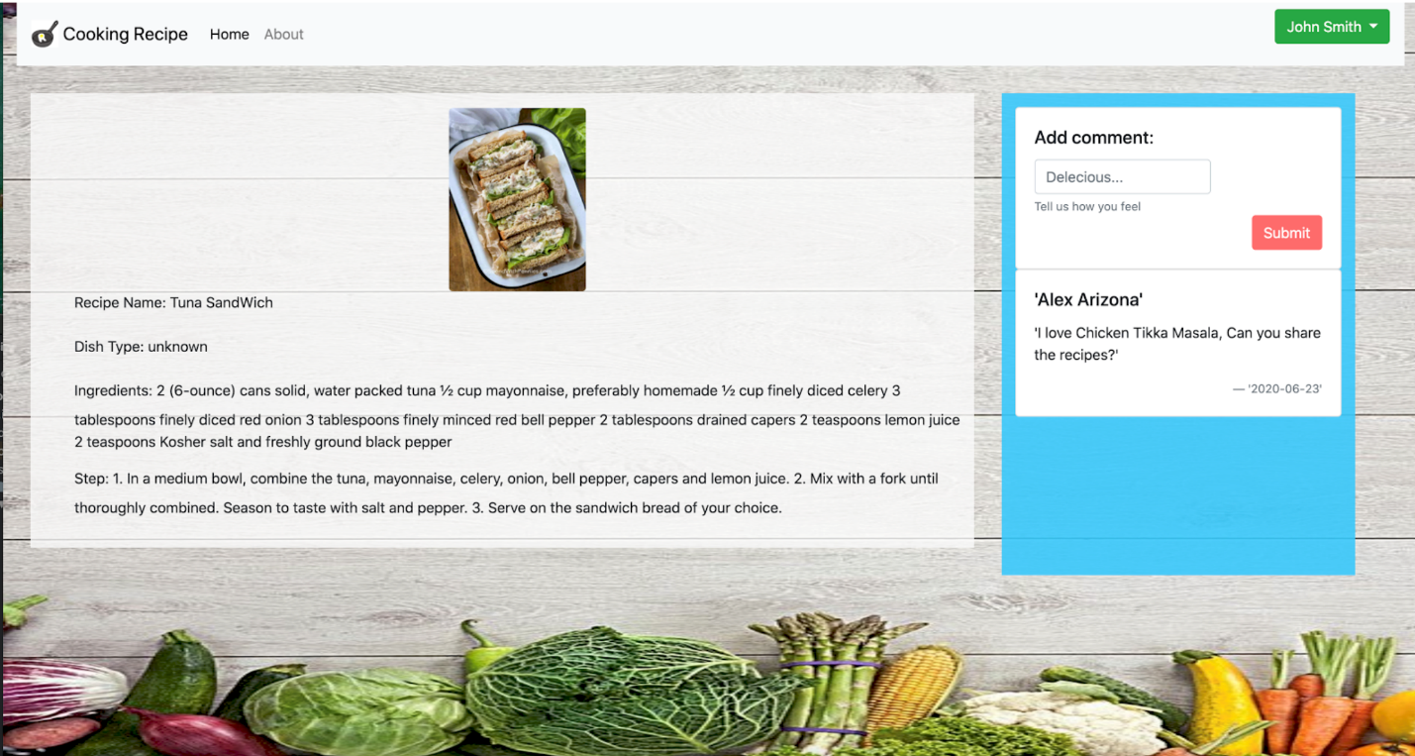](https://github.com/guiller-d/waving_recipes/blob/master/screenshots/cr4.png)

**My Recipe Page**

[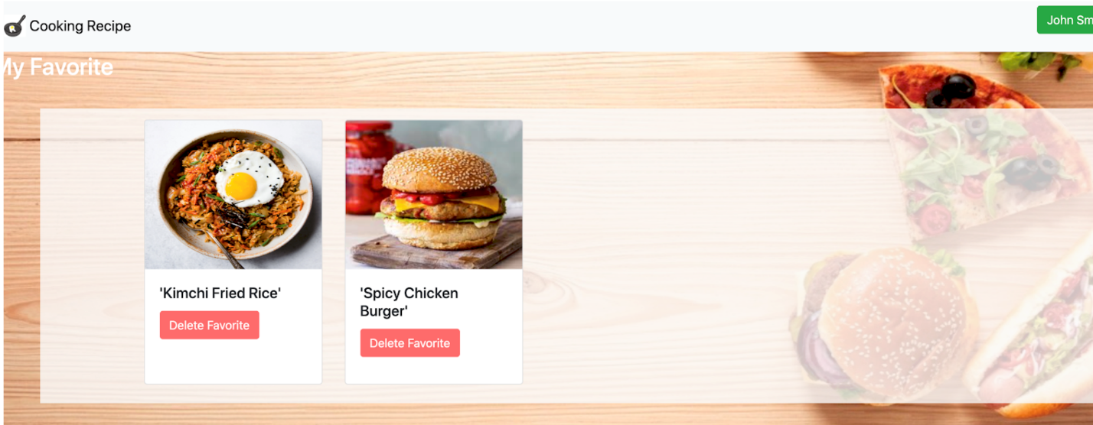](https://github.com/guiller-d/waving_recipes/blob/master/screenshots/cr6.png)

**Follower Page**

[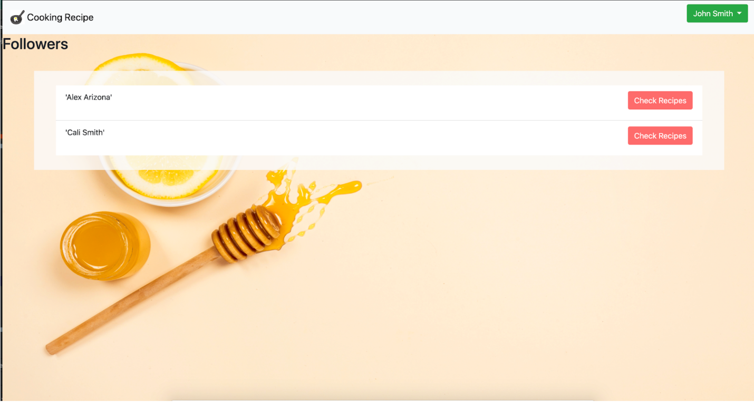](https://github.com/guiller-d/waving_recipes/blob/master/screenshots/cr7.png)

**Add New Recipe Page**

[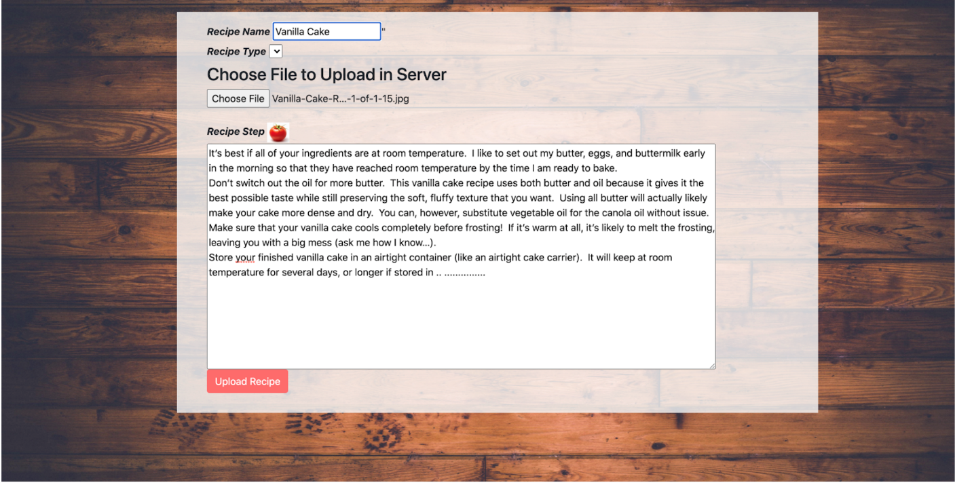](https://github.com/guiller-d/waving_recipes/blob/master/screenshots/cr10.png)